Project Proposal of Software Engineering Project (II): Web Programming

Title of the project

Student Portal

Name of Student: Shabbir Ahmed Shakib
ID: 142-35-664

Supervised By Submitted To
Md. Alamgir Kabir
Name of Supervisor Md. Alamgir Kabir
Designation: Lecturer Department of SWE
Department of SWE Daffodil International University
Daffodil International University

1. Project Title
Student Portal

2. Background
of Proposed Project
A student portal is an online gateway where students can log into a school/ varsity websites to access important program information and teachers can add results of the students . It is very necessary for the students.They can easily see the result from anywhere. In addition to regular web pages, the Student Portal serves as an interface to a range of services in different systems. Links between systems can sometimes make the Student Portal slow. The Student Portal has a responsive design i.e. the design adapts to fit the size of the screen regardless of browser or device.

3. Objectives of the Project

The main objective behind construction of this portal is to provide a single place to students from where they can do all the study related activates without login to different websites. In other words, it is very necessary for the students that they can easily see the result from anywhere.

4. Expected Outcomes

- Adding result,
- Showing result,
- Searching result,
- Login,
- Registration etc

5. Proposed Activities

1. Login,
2. Registration,
3. Search result according to ID,
4. Add result,
5. Online Attendance,
6. Live teaching evaluation

6. Estimative Budget

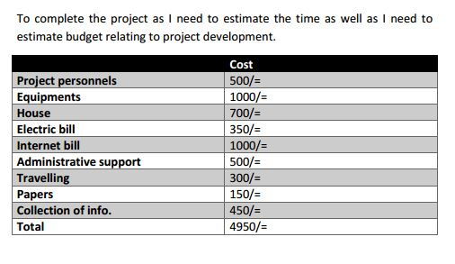

7. Project Timelines
In this report, an information system’s development has been presented. It was emphasized
on the basic steps, consequently taken during the project’s development course as a particular attention was turned to the basic operative functions performed upon the data into the database.
From our project, Student and Teacher of our country will get a great benefit from this. At last I will thank our honorable teacher Mushfiqur Rahman to help us in making this project.

8. References
https://docs.microsoft.com/en-us/
http://stackoverflow.com/
http://studentportal.diu.edu.bd/loginhttps://www.youtube.com/user/kudvenkat
www.capterra.com
www.getapp.com

